Notes – December 4, 2019
Community Support Network Partner Meeting
3:30 to 5:00 pm – Gene Albaugh Community Room at the Madelyn Helling Library
3:30  3:35 | Welcome & Introductions – Laura Harter, Coordinator of the Family Resource Centers and CSN-CAPC Board Chair  Meeting Minutes  Accepted minutes from November meeting
3:40 | Meeting Focus – Be the One  Partner Meeting Notes December 4, 2019  Be the One Presentation by Eli Gallup and Marina Bernheimer (presentation and attachments to be available on CSN Be the One Page). Be the One promotes discussion about ACES and resiliency and provides an activity for reflection on how individuals and organizations can make a difference and connect compassionately with others at home, in the workplace, neighborhoods, schools, online, and also with oneself for better self-care. Discussion about challenges for service providers to truly listen, challenges to spreading the word about the impact of childhood trauma to non-social work community, and challenges at work when stress rises and gossip occurs, and challenges for self-care. Several members expressed interest in forming work group to promote Be the One and Dena Malakian, Carol Grant, Shelley Rogers, Remy Lindsay, Serenty Madison, Whitney Logue, and Schulyer Bright came forward to start action group. CSN will follow through and convene a meeting.
4:45 | Network Announcements Shelley Rogers, from Granite Wellness shared a link to Placer County 2 day Motivational Interviewing training in December.
5:00 | Adjournment – Next meeting February 5 (January is a hiatus). Connecting Point is coordinating Census 2020 outreach efforts in Nevada County. One of the groups considered "hard to count" for the Census is children aged 0-5. Learn about the importance of the census to our community and how we can work together to "get out the count."  We welcome your help stacking tables and chairs. Thank you!  Upcoming 2020 CSN Partner Meeting Dates: January-hiatus, February 5, March 4, April 1, May 6, June 3, July & August-hiatus, September 2, October 7, November 4, December-hiatus

Community Support Network of Nevada County Meeting Agreements
- Make decisions by consensus.
- Create an atmosphere of mutual respect that includes active listening and listening without judging.
- Start and end on time.
- Maintain a sense of humor and a positive attitude.
- Bring concerns to the whole group. Don’t take them to the parking lot after the meeting.
- Set up the room in an inclusive way.
- Take responsibility for a task only if you have the time to accomplish it.
- Everyone is empowered to be a process observer and take ownership for the health of the meeting and is responsible for the health of the whole meeting.
- Be sensitive to others’ need for more information. Make sure everyone understands. Be careful of injecting your self-interest and label it as such. Be able to articulate your agency’s interest and be open to other’s interests.
- Meetings are meaningful and have a shared purpose.

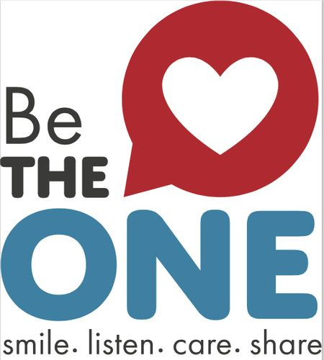
The Be the One campaign raises awareness of the power of connection. Changing a person’s life for the better can happen with one positive connection with just one person. We know this in our hearts and there is research to support it.
Being the One for others is a simple way to put trauma/healing informed practices into action and transform our own lives, our families, and our communities. The Be the One campaign is a way to dialog about the impact of Adverse Childhood (and Community) Experiences (ACES) and the science of resilience to harness the power of connection. ACEs have deep and lasting harmful impacts on the lives of those that experience it, and positive connections build resilience to overcome ACEs. Join us!
Learn more at csnnc.org/be-the-one

