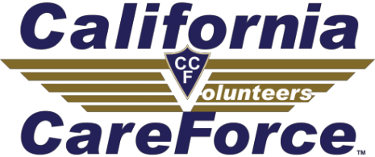
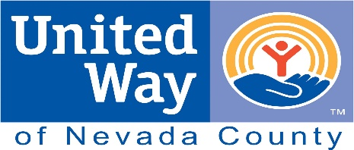

Grass Valley Free 2-day Health Clinic

HEALTHCARE PROFESSIONALS COME TOGETHER TO
SERVE THOSE IN NEED
Two key partners have signed on to aid in the overseeing of the second two-day free medical clinic in Grass Valley, this time set for Jan. 11 and 12 of 2020. Organized in conjunction with the Roseville-based nonprofit California CareForce, United Way of Nevada County will be hosting the event, which will take place at the Nevada County Fairgrounds for the first time.
Free dental, vision and medical care will be offered to uninsured and underinsured individuals and families in the Nevada County area on January 11 and 12, 2020 at the Nevada County Fairgrounds in Grass Valley. More than 300 volunteer healthcare professionals from throughout California are projected to provide critical care for an anticipated 500+ people per day. All services are FREE; clinic participants need NO proof of insurance, employment, income, residency, immigration status or an ID to receive them.
The clinic will have 60 dental chairs, ten medical exam rooms, and four vision lanes. A vision lab will produce free prescription eyeglasses on-site. Dentistry will include x- rays, cleanings, fillings, and extractions. Medical doctors will provide services ranging from consultation and diagnosis to minor medical procedures while nurses will staff triage areas and provide medical assistance.
“We are happy to be back in Grass Valley to provide our free clinic to all those in need,” said Pamela Congdon, California CareForce Founder and Executive Director. “The patients are so grateful that somebody cares about them. They are receiving healthcare services they would not be able to access elsewhere. The Grass Valley community has come together to make this clinic the best it can be.”
United Way of Nevada County CEO, Megan Timpany said, “United Way and the Health Clinic planning committee have been hard at work on the clinic for over a year. It is really exciting to be able to be involved with such a great collaboration that will bring beneficial impact to individuals in our community.”
All patients must have a wristband to receive services. Wristbands for next-day services will be distributed as follows:
Truckee Area Residents: Friday and Saturday, January 10 and 11 from 2pm - 4pm at the Sierra Community House, 11695 Donner Pass Road, Truckee Grass Valley Area Residents: Friday and Saturday, January 10 and 11 from 4pm - 6pm at the Nevada County Fairgrounds, 11228 McCourtney Road, Grass Valley
Professional volunteers are still needed in numerous capacities including general dentists, dental hygienists, dental assistants, dental x-ray techs, oral surgeons, optometrists, opticians, ophthalmic techs, physicians, nurse practitioners, chiropractors, RNs, EMTs and more!
For more information on volunteering or receiving services, please visit www.californiacareforce.org or contact Volunteer & Outreach Coordinator, Emerald Carroll, at 916-749-4170 or emerald@californiacareforce.org

California CareForce is Tax exempt under Section 501(c)3 of the IRS Code. EIN 45-2408171
United Way of Nevada County is a 501(c)3 organization. Tax ID #68-0007201

