006 - CSN Phone - Verizon

**Each month's bill is set up to be auto-paid from CAPC checking account. See more info about that below.** Passwords will be held by CSN Coordinator and one or more members of CSN-CAPC Board.

Verizon Wireless

530-913-0270

Password for voicemail: See page 002

The physical phone is an old Verizon flip phone.

Username: CAPCWNC

Password: See page 002

Customer service: 1-800-346-0508

Account #: 571018585-00001

Billing system password: See page 002

This is different from the login or voicemail passwords. From the website: "You will be asked for your Billing Password when you contact Customer Service or when you perform certain online actions. A Billing Password is not the same as your My Verizon password."

Corporate or Organization #: 1239399

Federal Employer ID #: 68-0026014 (may need to use "6404" as last four digits - a vestige of the involvement of Chuck Coovert, former CAPC Board member)

Here are two scans of info about the history of the phone.

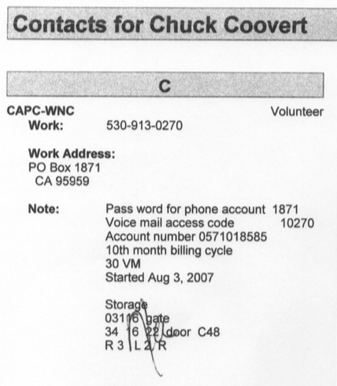

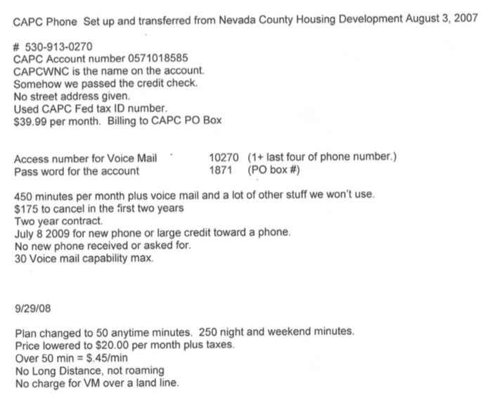

TO LOGIN TO CHECK BILL

We get an email each month saying the new bill is available to view. Click link in the email or go to www.vzw.com (same as: login.verizonwireless.com). This notice comes about the 13th of the month, and the bill is auto-paid by about the 5th of the next month. To login on the login page, enter phone number or username noted on prior page, then enter password. See page 002.

On April 21, 2016, Susan Sanford and Lindsay Dunckel spoke with Francesca at Verizon about account updates and getting things set up to auto-pay the phone bill each month from the CAPC checking account.

Security image: See page 002

Secret question for Verizon CAPCWNC phone

Q: What is the name of a memorable place?

A: See page 002 for answer

PENDING AS OF JUNE 29, 2016 - April 22, 2016 email to CORebusinessdocs@verizonwireless.com to update POC (Point Of Contact) info to replace Chuck Coovert with CSN Coordinator and Lindsay S. Dunckel. Fax is 866-344-5285.