005 - CSN MailChimp

MailChimp automatically grabs content from the CSN website News page (posts are created as described on WordPress page 004) and sends out our weekly e-news. The CSN Coordinator maintains the database of email addresses in MailChimp, and logs in to check the appearance of the e-news after the new posts have been created in WordPress. Content that is grabbed is anything that has been posted since the prior week's e-news went out, and MailChimp will grab a maximum of 10 posts.

To access, login. First time go to www.mailchimp.com. Click Log In. Then proceed as shown below. Login page can be bookmarked for future use. Passwords will be held by CSN Coordinator and one or more members of CSN-CAPC Board.

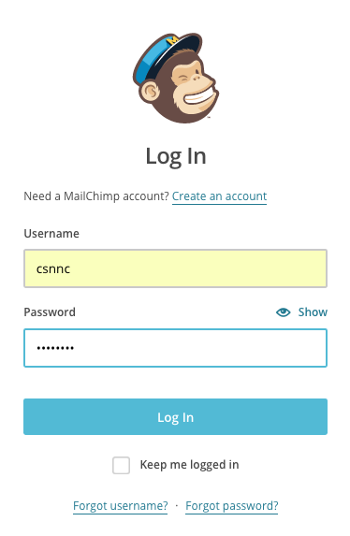

You will be logged in to the "Dashboard."

TO MANAGE LISTS

In menu at top, click Lists. Click csnnc. Select from options for whatever you want to do.

People can automatically subscribe to the MailChimp e-news from the CSN website "Contact" page. Their info will need to be added to the Gmail list manually by the CSN Coordinator. The Gmail and MailChimp lists are not linked to each other.

TO CHECK APPEARANCE OF E-NEWS

In menu at top, click Campaigns.

Move mouse to where it first says "CSNNC News," look to the far right and click arrow at Sent Campaigns.

In box that opens, click on View email.

A new window will open and you can scroll through to check spacing, etc. The way to adjust things is to go back into the post in WordPress and add/delete spaces, returns, etc. Update in WordPress, then refresh MailChimp window to see changes.

Because our "campaign" title is the same every week, we have maxed out the number of test emails we can send ourselves to check formatting (this would be available for a monthly fee). **Also, not all images appear in what comes up when you click "View Email." (Very disconcerting!) But if images are in the WordPress posts, they should appear in the Tuesday e-news.**

TO LOGOUT -

(If you are in "View Email" click browser back arrow to return to "Campaigns" page.)

Go to top right and click on where it says "csnnc." A box will open where you will see "Log Out." Click on that!