003 - CSN Gmail

CSN Gmail address is: [csnncorg@gmail.com](mailto:csnncorg@gmail.com)

PLEASE NOTE: Google changes the appearance of the user interface from time to time. This page may not always have the current visuals.

To access CSN email, login. First time go to www.google.com, click on Gmail. Then proceed as shown below. Login page can be bookmarked for future use. Passwords will be held by CSN Coordinator and one or more members of CSN-CAPC Board. (Susan had more than one gmail account which is why it says “Choose an account.”)

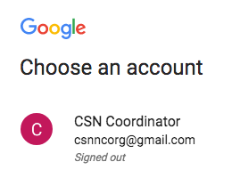 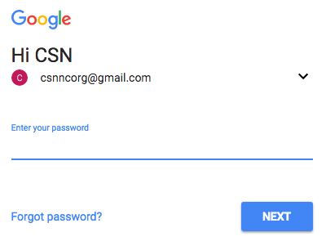

There are a number of email groups, but the ones that are used most are the two "CSNNC” sub-groups and "CSN-CAPC Board.” The CSNNC list is split in two because we have too many in the main group for a single email to go to all, so all emails to CSNNC partners get sent to both sub-lists. Those lists are called, “CSNNC-a to m-first name” and “CSNNC-n to z-first name.”

When people get added to the CSN email lists, they are added to the big CSNNC Gmail group, AND to their sub-goup, AND to the MailChimp database (described elsewhere).

How to use Gmail is not covered here :-)

To logout, click on the "C" at top right. A box will open where you will see "Sign out." Click on that!