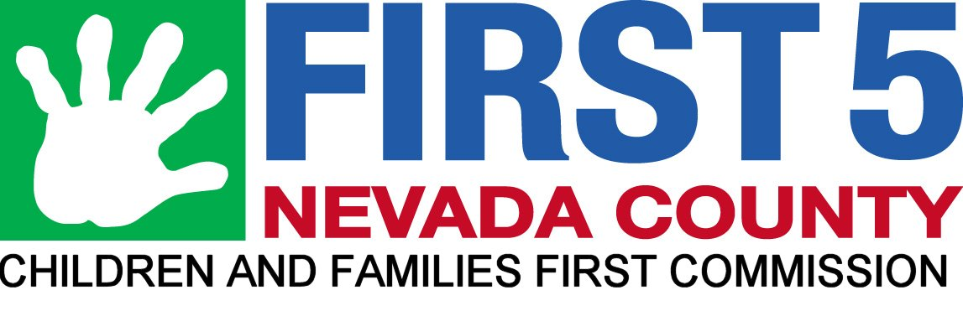
Community Support Network of Nevada County
2017-2018
Budget: $12,500

Numbers Served July 1, 2017-June 30, 2018
- More than 60 organizations have attended 9 CSNNC Partner meetings
- 247 total Partner meeting participants (average of 27 per meeting)
- 12 Steering Committee meetings (average of 9 individuals attend monthly)

Meeting Topics
FY 2017-2018 Meeting Dates & Topics (December, July, and August hiatus)
- September 6th - The Continuing Housing Challenges in Nevada County
- October 4th - Shaken Baby Syndrome
- November 1st - Sharing the Holiday Spirit – resources for kids and families from
- January 3rd - A Guide to Self-Care to Start the Year Off Well
- February 7th - Mapping the Five Protective Factors in Nevada County
- March 7th - Identifying & Addressing Childhood Developmental Issues Resources
- April 4th - Current Drug Use Trends Impacting Children and Youth in Nevada County
- May 2nd - Transition to Adulthood Planning for Youth with Special Needs
- June 6th - Becoming a Trauma-Informed Community

Participant Satisfaction
Our primary function is as a collaborative convener of local family service agencies.
- We use an evaluation form at all of our meetings. Information from these is used to inform future programs and initiatives. Evaluations solicit metrics on usefulness of information obtained. On a scale of 1 (low) to 5 (high), the average is above 4.
- Partner meeting attendance numbers are steady (avg. 27 per meeting).
- The weekly e-newsletter has a subscriber "open" rate of 22% which is the non-profit industry average. In years past it has been as high as 32%. Decline may be due in part to people getting ever more emails and e-newsletters.

Outcomes
- Facilitated and coordinated 9 CSNNC Partner meetings, all of which are open to the public
- Halloween Book Giveaway at which 827 books were given to preschool children
- "Kids Corner" at the Nevada County Fair partly staffed by CSNNC Partners, gave out 850 books
- Send weekly e-newsletter to list of approximately 500 subscribers
- Kids Safety & Health Carnival partly funded by CAPC/CSNNC, 400 attendees
- Trauma-Informed Care training. 46 attended.
- In April 2017, for Child Abuse Prevention Month, our colleagues at the Yolo County Children’s Alliance produced two outstanding self-care documents:
• a large trifold guide called “Make Time for Yourself – a self-care guide for busy parents”
in both English and Spanish
• a card called “Make Time for Yourself – Start a Conversation”
CSN worked with YCCA to adapt the contents for Nevada County, and the documents are
available on the CSN website and in printed form at CSN meetings.
In FY 2017-18 we gave out about 100 English brochures, 75 Spanish brochures, and 100 cards.
- Created informative certificate for Shaken Baby Syndrome. Purchased 1000 at end of FY. Will distribute in FY 2018-19.

Quotes from meeting evaluation forms: The most valuable part of the meeting was...
- Powerful speaker; great information (about Shaken Baby Syndrome)
- Having school resource officers talk about what is happening on campuses around drug use; learning about vaping issues.
- Learning community partners' roles and scope of service (for Transition to Adulthood Planning for Youth with Special Needs)
- Lots of great data and resources. Love the idea of working toward a trauma-informed community.
- Information I can share with staff at The Clinic. I've never thought to ask medical staff how they deal with client trauma.

